Dear Friends,

You are warmly invited to join our community circle 4.30 pm on Sunday 24th June, as we offer a special 5oth anniversary session of the Dances of Universal Peace.

The dances are a prayer for peace within and without begun by Samuel L. Lewis (SAM) 50 years ago this June.

A renowned spiritual leader from San Francisco in the 1960’s, SAM promoted peace and integration within individuals and groups worldwide. The dances he created drew from many spiritual traditions and have expanded in the last 50 years to include many more.

SAM famously said that if humanity came together to ‘Eat, Pray and Dance’ we would inhabit a happier planet.

Come and join with us in this 'body prayer' as we, in our time, step into that river of awareness and devotion, honouring the many gifts of this beautiful shared practice.
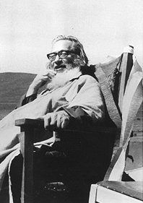
No previous experience necessary.

Venue: The Great Hall at Tauhara Centre
Time: 4.30pm this afternoon Sunday 24th June
Koha/Donation - however, please know that you are welcome
regardless of money
Potluck dinner: bring food to share
Leaders: Jane~Hadia Penton and friends (phone 07 378 2043)

"May All Beings Be Well, May All Beings be Happy - Peace, Peace, Peace”

Tauhara Retreat & Conference Centre
60 Acacia Heights Drive, Acacia Bay, RD 5, Taupo 3385, NZ, ph: (07) 378 7507
fax: (07) 378 7528
tauhara@tauharacentre.org.nz
www.tauharacentre.org.nz
Tauhara Centre is an educational charitable trust registered with the NZ Charities Commission
Support Tauhara: Donate Now!

